CRITICAL THINKING SKILLS OF YEAR 10 SANGUINIS STUDENTS IN LEARNING BASED ON NITENI, NIROKKE, AND NAMBAHI
Fuji Astuti¹, Sri Adi Widodo^{2*}, Irham Taufiq³, Widowati Pusporini⁴, Kamarul Ariffin Mansor⁵
¹Universitas Sajanawiyata Tamansiswa, Jalan Batikan UH III/1043, Yogyakarta, 55167, Indonesia.
astutifuji2603@gmail.com
²Universitas Sajanawiyata Tamansiswa, Jalan Batikan UH III/1043, Yogyakarta, 55167, Indonesia.
sriadi@ustjogja.ac.id
³Universitas Sajanawiyata Tamansiswa, Jalan Batikan UH III/1043, Yogyakarta, 55167, Indonesia.
irham.taufiq@gmail.com
⁴Universitas Negeri Yogyakarta, Colombo Street No 1, Karang Malang, Yogyakarta, 55281, Indonesia.
widowatipusporini@uny.ac.id
⁵Universiti Teknologi MARA (UiTM), Kedah Branch, Malaysia.
ariff118@uitm.edu.my
ABSTRACT
The study aimed to examine whether Tri-N-based trigonometry instruction improved students' critical thinking skills and sanguine personality. Single-subject research with an ABA design was the method used in this study. The stages of this study were the initial Baseline (A), the Intervention (B), and the second Baseline (A'). Year 10 science students with sanguine personalities who were chosen using a purposive sampling technique served as the study's subjects. This study employed observation methods, testing tests, and documentation for data collection. Data analysis within and between conditions are the methods used to analyze data. The findings of this study revealed that using Niteni, Nirokke, and Nambahi learning on trigonometry improved students' critical thinking skills with sanguine dispositions.
ARTICLE INFORMATION
Keywords |  | Article History
Critical Thinking Skills  Personality  Sanguinis  Tri-N |  | Submitted Jul 17, 2023  Revised Oct 11, 2023  Accepted Nov 13, 2023
Corresponding Author
Sri Adi Widodo
Universitas Sarjanawiyata Tamansiswa
Jalan Batikan UH III/1043 Yogyakarta 55167
Email: sriadi@ustjogja.ac.id
How to cite
Astuti, F. et all. (2023). Critical Thinking Skills With Sanguinis In Class X Learning Based On Tri-N. Kalamatika: Jurnal Pendidikan Matematika, 8(2), 149-176.
https://doi.org/10.22236/KALAMATIKA.vol8no2.2023pp149-176

INTRODUCTION
In the 21st century, it is an essential role for teachers and students as a form of change in learning activities. Students are required to have more critical thinking patterns. This is summarized in 4C: Critical Thinking, Communication, Collaboration, and Creativity (Istiqomah & Indarini, 2021; Kivunja, 2014; Rachmadtullah et al., 2020). These four abilities indirectly greatly influence the ability to innovate and the ability to solve problems. Therefore, in learning mathematics, students must think critically to solve problems (Ernest et al., 2016; Tanujaya et al., 2017). For pupils to become accustomed to arriving at decisions and conclusions using logic, reason, critical thought, care, efficiency, and practicality (Ibrahim et al., 2021; Umar et al., 2020). So, the need for necessary thinking skills is closely related to the world situation, which is dynamic, rapidly changing, and unpredictable. One needs critical thinking skills to analyze, assess, and come to the correct conclusions regarding a problem (Janah et al., 2019).
Educators should incorporate non-routine mathematics problems into the learning process to foster students' critical thinking skills. This approach is advocated because non-routine questions direct students' attention to the problem, aiding them in effectively identifying and comprehending the underlying issues. Additionally, students can discern the authentic nature of the problem and, subsequently, formulate predictions on how to address the challenges they encounter (Mahmuzah, 2015). Notably, non-routine problems in mathematics constitute a valuable facet of mathematical problem-solving (Fadillah, 2009; Shadiq, 2004; Widjajanti, 2009).
Non-routine problems inherently challenge students to respond and solve them. However, a pervasive issue lies in the fact that the mathematics questions presented to students in school settings do not sufficiently cultivate critical thinking skills. Consequently, students often exhibit limited proficiency in critical thinking (Sulistiani & Masrukan, 2016). This deficiency is further exacerbated by teachers who have not adequately trained students in problem analysis and the interpretation of facts. As a result, students in these schools achieve notably low levels of productivity (Falahudin et al., 2016). Previous research conducted on 58 students at one of the Islamic junior high schools in Mande, Indonesia revealed that students' overall critical mathematical thinking abilities fell within the low category (Hidayat et al., 2019). A similar trend was observed among eighth-grade students at one of the junior high schools in Pekanbaru, Indonesia regarding spatial construction material, indicating relatively low critical thinking skills (Putri, 2018). Correspondingly, a study involving fourth-grade students at a primary school in Sebungkang, Indonesia, demonstrated that the percentage of critical thinking skills was at 29.58%, meeting the criteria for low proficiency (Dores et al., 2020).
Several aspects, including personality type, can influence students' critical thinking processes (Thalhah et al., 2020). Personality is one characteristic of human behavior. Personality is the dynamics of a functional human psychophysical organization that turns into specific behavior patterns in dealing with life. A person's personality refers to how they appear and make an impression on others. Every human being has a different personality type. Some have a gentle, cheery, and friendly character. Some have other personalities, such as shyness, stubbornness, and others. According to the Hippocrates-Galenus typology theory, humans possess several personality types, including the sanguine personality type (Setyawati et al., 2018; Thalhah et al., 2020). The link between critical thinking and personality is that not all students can apply their critical thinking skills well when faced with a problem. This indicates difficulties for students in developing their critical thinking skills. When viewed from personality types, students with different personality types will have various challenges in developing their critical thinking skills to solve problems (Arifianti & Ismail, 2018). This personality type influences attitudes adjusting to socializing with their environment, including learning (Arum, 2021).
The results of observations at a high school in Yogyakarta, Indonesia, on January 27, 2023, revealed several issues, including the minimum completeness criteria that remained below average for Year 10 Science students. This is attributed to a classroom learning environment dominated by the teacher, resulting in passive student engagement. This observation aligns with the assertion that a lack of emphasis on understanding concepts and learning processes in the classroom tends to foster teacher-centric dynamics, making students passive and contributing to low academic achievement (Oda et al., 2022). Furthermore, students' attention is notably divided due to the pervasive use of cellphones during class, leading to a situation where students are engrossed in their phones rather than focusing on the material explained by the teacher. Insights from interviews with one of the mathematics educators at the school indicated that students face challenges in comprehending the taught material, causing the learning pace to be slow. Educators express concern about continuing to the next topic, fearing that students may not grasp it adequately, as they exhibit reluctance to pay attention during lessons. Additionally, during tests, students often provide answers that deviate from the questions posed. Therefore, it is imperative to consider and closely monitor students to ensure they can fully engage in ongoing learning activities.
Each student possesses distinct characteristics, encompassing diverse interests, preferences, backgrounds, and cultures, rendering them uniquely different. Even among twins, who may share a physical resemblance, individual characteristics diverge significantly. These divergent attributes collectively contribute to the uniqueness inherent in each student, observable through their abilities, learning styles, and factors that capture their attention. To categorize students based on shared traits, teachers often employ groupings that consider learning style, gender, ethnicity, culture, social status, interests, cognitive development, initial abilities, motivation, emotional development, social development, moral development, and spiritual outlook. Temperament-based characteristics further categorize students into four groups, including the sanguine personality (Buckingham, 2002; Doody & Immerwahr, 1983). The sanguine temperament views problems as new and exciting challenges, displaying enthusiasm for swift resolutions. However, due to its mercurial nature, individuals with a sanguine personality may quickly abandon a task if an immediate solution is not apparent (Sardia et al., 2020). Known for sociability and a proclivity for group activities, the sanguine personality is often associated with charismatic figures possessing persuasive intelligence and a desire for recognition within their environment. Individuals with a sanguine personality type exhibit remarkable openness, characterized by their conversational nature, adaptability to various settings, friendly demeanor, and warmth. They are responsive and possess a sense of humor, embodying amiability and spontaneity. Rather than dwelling on unimportant matters, individuals with a sanguine personality prefer to savor the joy of each passing day, displaying a carefree attitude toward the past and the future.
According to earlier studies, students who have a sanguine personality type understand the issue at hand even though they do not explicitly state it in writing, make a settlement plan but do not expressly state it in writing but instead directly apply the findings of their research to solving the issue, put strategies into practice by completion, and review their responses (Octaviani et al., 2018). The results of this study indicate that people with the sanguine personality type tend to have an optimistic, cheerful, and cheerful attitude. They also love adventure and have a high tolerance for risk. However, people with this personality usually cannot stand boredom and will seek a variety of entertainment (Widarni & Mora, 2021). The character of sanguine students in answering the problems given is optimistic, full of curiosity, innovative and able to come up with brilliant ways so that students with a sanguine personality can think critically when facing the problems given (Arifianti & Ismail, 2018). The results of previous research stated that sanguine students meet five indicators of critical thinking skills: indicators of interpretation, evaluation, inference, explanation, and arrangement (Fitria & Siswono, 2014; Hastari & Wardani, 2022). Other research results showed that sanguine students in solving problems met five of the six indicators of critical thinking ability, namely focusing on questions, inducing and considering the effects of induction, making and determining the results of considerations, identifying terms and considering a definition, and determining an action (Arifianti & Ismail, 2018).
Based on the previous description, the researcher is interested in developing students' critical thinking abilities in Year 8 trigonometry learning based on Tri-N. For this reason, this study aimed to determine the increase in students' critical thinking skills with sanguine characters in Tri-N-based learning on trigonometry. One way that can be done by teachers in developing necessary thinking skills is by using the Tri-N teachings. Three phases in Tri-N teachings are as follows. Niteni: students first observe and pay close attention to the teacher's directions and explanations about the material being studied; Nirokke is an imitating activity. In this phase, the teacher must ensure that students understand well what has been conveyed to imitate each material or problem-solving step; and nambahi, where students can develop other problem-solving methods to hone critical thinking skills (Nisa et al., 2019).
Many studies have been conducted on student characteristics such as sanguine. They focus more on profiling critical thinking skills (Arifianti & Ismail, 2018; Hastari & Wardani, 2022), creative thinking skills (Azis, 2018; Fitria & Siswono, 2014), and problem-solving skills (Nilamsari & Fitriyani, 2021; Octaviani et al., 2018; Sardia & Ilyas, 2020). Likewise, many studies have been carried out on the Tri-N learning theme, such as increasing the creativity of elementary school students (Nisa et al., 2019), improving critical thinking skills (Sunarsih et al., 2023), implementation of Tri-N to develop student character (Ermawati & Rochmiyati, 2020), development of worksheet-based Tri-N (N. Istiqomah et al., 2021; Widyawati et al., 2019; Wijayanti et al., 2021). However, there is limited research on enhancing critical thinking skills through Tri-N learning, specifically in sanguine subjects. Similarly, no researcher has undertaken such an investigation in sanguine studies employing a single-subject research design. This distinction sets apart the ongoing research from previous studies conducted in this domain.

METHOD
The research methodology used in this study is single-subject research using the ABA design. The dependent variable and independent variable have a causal relationship. If the independent variable changes, the dependent variable will also change. Single-subject research is an experimental study that looks at behavior and evaluates specific interventions from a subject, with research carried out repeatedly at a particular time (Gast & Ledford, 2014; Prahmana, 2021; Widodo, Kustantini et al., 2021). The advantages of the single subject method include (1) Researchers can investigate whether an intervention works, (2) they can see the effects of the intervention provided quickly, (3) they can observe changes in the subject's behavior from day to day if changes are needed then changes can be made immediately the next day, (4) If you use research with a large sample size, it will take a long time to test an intervention on the subjects of observation (Heryati et al., 2022; Prahmana, 2021; Ramadhan et al., 2022). These four advantages are the reason for using single-subject research on phlegmatic students to improve critical thinking skills using intervention in the form of learning with Tri-N.
Initially, the subject was measured for their initial critical thinking skills in the first baseline phase (A) within a certain period, followed by treatment in the intervention phase (B). Furthermore, the subject was re-measured for his critical thinking skills after therapy in the baseline-2 grade (A'). Adding this baseline-2 condition as the control for the intervention phase, it is possible to conclude that there is a functional relationship between the independent variable and the dependent variable (Sumanto et al., 2005). The dependent variable is the critical thinking ability of students with sanguine personalities in trigonometry, and the independent variable is the Tri-N-based learning concept's application (Niteni, Nirokke, Nambahi). In general, the diagram for the research flow of the single-subject research method can be seen in Figure 1.

Second Baseline (A’)
- Face-to-face learning on sanguine without using Tri-N.
- Number of face-to-face meetings at least 3 times
- The purpose of the second baseline is to determine the final ability of sanguine students regarding critical thinking skill.
First Baseline (A)
- Face-to-face learning on sanguine without using Tri-N.
- Number of face-to-face meetings at least 3 times
- The purpose of the first baseline is to determine the initial ability of sanguine students regarding critical thinking skill
Intervention (B)
- Face-to-face learning on sanguine without using Tri-N.
- The number of face-to-face meetings is at least 3 times or until a stable state is obtained
- The purpose of the intervention is to determine the thinkin skill of sanguine students using Tri-N.
Figure 1. Desain of Research
This research was conducted at the subject's house, which is located in the Kalasan Sleman area of Yogyakarta. This research started on Monday, 10 April 2023, until Wednesday, 19 April 2023, for ten days. The subject in this study was Year 10 Science students with sanguine personality, who taking the subject using the usual consideration method and strengthened by using the Hippocrates-Galenus typology personality test. The subject characteristics fulfilled were a sanguine student, with low critical thinking skills, and difficulty solving math problems.
The data collection technique used the observation method in the intervention phase, questions aimed at evaluating the subject's critical thinking skills, and documentation to document the activities carried out by students during the research. Content validity was tested using the Aiken index. The Aiken index is an index of rater agreement on the suitability of items with the indicators to be measured using these items (Aiken & Patrician, 2000; Aiken, 1980, 1999; Retnawati, 2016; Widodo, Ibrahim, et al., 2021). Content validity was estimated by testing feasibility through rational analysis by expert judgment (Aiken, 1980; Almanasreh et al., 2019; Crocker, 2015; Sireci, 1998). The data was analyzed using data analysis in conditions and inter conditions (Lane & Gast, 2014; Prahmana, 2021; Widodo et al., 2020; Widodo, Kustantini, et al., 2021). Analysis of conditions include condition length, trend direction, level of stability, data trace, strength and reach level, and change level. The number of variables modified, changes in trend and impact, changes in equilibrium, changes in levels, and data overlap are all included in the analysis of interstates, all are included in data analysis between conditions.
RESULT AND DISCUSSION
Result
The single-subject research employing an ABA’ design consists of three phases. Three sessions were conducted to examine students' initial proficiency in the initial phase, referred to as baseline-1 or the first baseline (A). During this stage, participants worked on two trigonometry problems, with each session lasting 40 minutes. Subsequently, the second phase involved intervention (B), which was implemented four times, with each session lasting 60 minutes. The intervention consisted of Tri-N-based learning. Post-learning, participants were tasked with solving two long-answer trigonometry problems. The final phase, baseline-2 or the second baseline (A'), was conducted thrice, each session lasting 40 minutes. In this phase, the subject's critical thinking skills were assessed post-intervention by completing two long-answer trigonometry problems. The research data generated by the subject during trigonometry learning activities were focused on the initial baseline (prior to treatment), intervention, and second baseline (post-treatment).
First Baseline (A)
The data in this phase were obtained through the researcher's observation of the subject's initial abilities, namely the results of solving two long answer problems before using Tri-N-based learning and before the treatment (intervention). The stages were completed in three sessions by working on a critical thinking skill test on trigonometry in two long answer problems. The duration of each session was approximately 40 minutes. In this phase, the subject is asked to work on the questions independently without the help of a book or other aids. This aims to measure the subject's initial knowledge before the treatment. The test results in the first baseline phase are summarized in Table 1.
Table 1. Critical Thinking Skills data in First Baseline
No. | Session | Score
1. | Session 1 | 35
2. | Session 2 | 40
3. | Session 3 | 45
Average |  | 40

Table 1 shows that the test results remain low due to the subject's ongoing difficulty in comprehensively addressing the problems, as the responses primarily consist of the subject's interpretations of what is known and what is asked. The outcomes of the critical thinking skills test during the first baseline (A) are illustrated in Figure 2 to provide a visual representation and enhance the clarity and accuracy of the data.
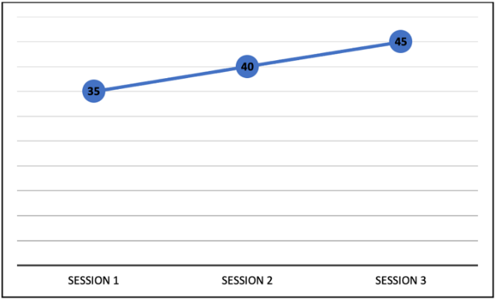
Figure 2. Graph of Critical Thinking Ability Test Data in First Baseline
Intervention (B)
The intervention phase (B) was carried out in four sessions, and each session was given approximately 60 minutes. The intervention given is Tri-N based learning (Niteni, Nirokke, Nambahi) with the help of Trigonometry material PowerPoint. At the Niteni stage, the subject observes the researcher's explanation of PowerPoint, and If the matter is still unclear, he can consult the researcher.
In the Nirokke stage, the subject was given two critical thinking skills test items as it is the imitating stage of what the subject had observed at the Niteni stage. At this stage, the subject was allowed to reopen the PowerPoint that was previously submitted. The final step was Nambahi. The subject must convey his findings or answers to the two problems. Sanguine students' responses were conveyed verbally and in writing. The researchers observed indicators of critical thinking skills that emerged in students' communication regarding the answers given by sanguine students. The indicators of critical thinking skills used as observation guidelines are about interpretation, analysis, evaluation and inference at this time. This is intended to determine the subject's critical thinking skills in presentation besides solving problems. The results of the intervention phase tests are summarized in Table 2.
Table 2. Data on Critical Thinking Skills in Intervention
No. | Session | Score
1. | Session 4 | 60
2. | Session 5 | 65
3. | Session 6 | 75
4. | Session 7 | 80
Average

Table 2 shows that the test results have increased even though the subject still committed some errors. The subject felt that he already knew due to the intervention phase. Figure 3 shows the results of the intervention phase test.
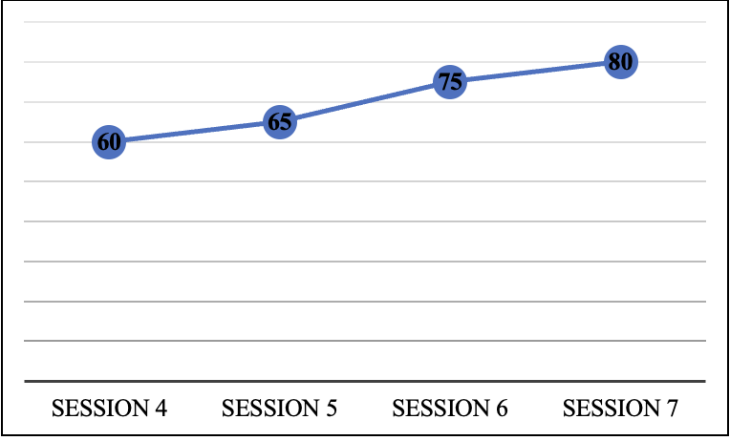
Figure 3. Data of Intervention Phase Critical Thinking Skills
Second Baseline (A’)
The second baseline (A') stage was carried out in three sessions. Each session lasts for approximately 40 minutes. At this stage, the subject is given two trigonometry-based critical thinking skills test problems to determine the subject's critical thinking skill following intervention using Tri-N based learning in this phase. However, in this phase, the subject cannot look back at the PowerPoint given during the intervention phase. The second baseline (A') phase's learning flow started with prayer, followed by working on assessments of critical thinking skills and learning, and ended with prayer. Table 3 lists the test outcomes for the second baseline phase.
Table 3. Data of Critical Thinking Skills in Second Baseline
No. | Session | Score
1. | Session 8 | 85
2. | Session 9 | 90
3. | Session 10 | 93.75

Table 3 indicates that the test results were much better than before the intervention. The subject was also ready and knew well the strategy for solving critical thinking skills test items. The subject's critical thinking skills can be categorized at a very high level. The test results in the second baseline phase are seen in Figure 4.

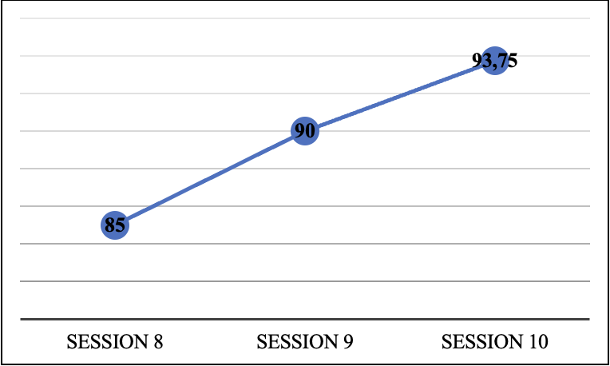
Figure 4. Graph of Critical Thinking Skills Test in the second Baseline
Obtaining data on measuring the subject's critical thinking skill in the baseline-1, the intervention phase and the second baseline can then be compared, as shown in Figure 5. This figure compares the overall results of the subject's critical thinking ability test with trigonometry material.
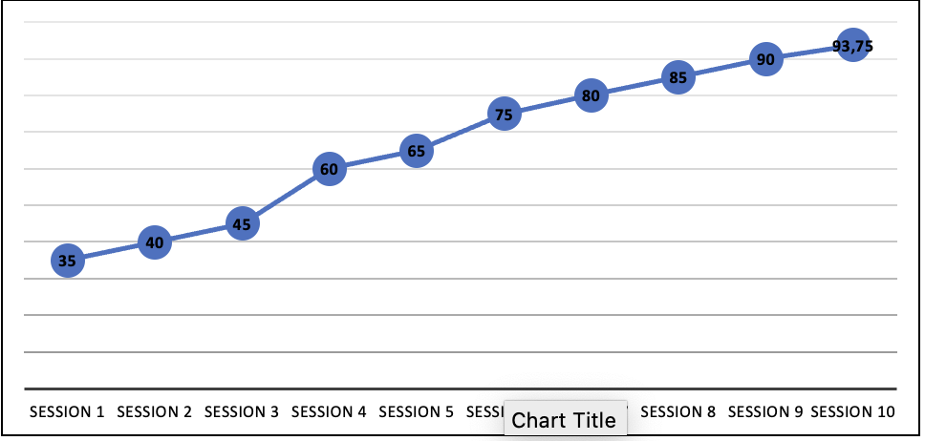
First Baseline (A)
Second Baseline (A’)
Intervention (B)
Figure 5. Graph of Critical Thinking Skills Test in the First Baseline, Intervention, And Second Baseline
In-condition and inter-condition analyses can be used to calculate research data. This analysis elaborates based on data changes in certain phase conditions: first baseline or initial baseline, intervention, and second baseline. The situation being analyzed is the condition of the subject's critical thinking skills. Data analysis under study conditions is shown in Table 5.
Table 4. Results of Analysis in Conditions
Condition | First Baseline (A) | Intervention (B) | Second Baseline (A)
Length of Condition | 3 | 4 | 3
Trend of Directional

Level of Stability | Stable  (100%) | Stable  (100%) | Stable  (100%)
Trail of data

Level of Stability and range | Stable  (33.25 – 46.75) | Stable  (58 – 82) | Stable  (75.5175 – 103.6425)
Level of Change | 35 – 45  (+10) | 60 –80  (+20) | 85 –93.75  (+8.75)

Table 5 shows three sessions in the first baseline, four sessions in interventions, and three sessions in the second baseline. Each session's directional trend in the subject's general capacity for critical thinking skills rose, which is enhanced the predisposition toward each phase.
The level of stability is measured as being 100% stable throughout all phases. To ensure that the data in the data trace and the directed movement are identical, establishing a condition in a data trail is similar to specifying a directional trend. Trace data in the first baseline phase, the intervention, and the second baseline are increasing. The level of stability is declared stable or unstable according to the calculation of the trend of stability that has been done before. The range is the distance between the first and last data. The first baseline (A) phase is stable because the field is 33.25 to 46.75. The stability level in the intervention phase (B) is stable because the range is 58.00 to 82.00. The stability level in the second baseline phase (A') is stable because the field is 75.52 to 103.60.
Subsequently, the magnitude of change was analyzed by calculating the difference between the largest and smallest data points for each step. The symbol "+" denotes an increasing change, "-" indicates a decreasing change, and "=" signifies no change. The rate of change in the data analysis during the first baseline phase (A) is +10, denoting an increase of 10. During the intervention phase, the rate of change is +20, indicating an increase of 20. In the second baseline phase (A'), the rate of change is +8.75, signifying an increase of 8.75.
Analysis of inter-conditions is a comparison of the state of one phase with another phase. The data analysis on inter conditions indicates how significant the impact of the intervention is on the research. Table 6 presents the Tresults regarding the analysis of inter-requirements.
Table 5. The Results of Analysis of Inter Conditions
Comparison of Inter Conditions | First Baseline/Intervention  (A1/B) | Intervention/Second Baseline  (B/A’)
The number of variables observed | 1 | 1
Changes in trends and their effects

Stability of Change | Stable | Stable
Level of Change | 45 to 60 (+15) | 80 to 85 (+5)
Data of overlap | 0% | 0%

Table 6 illustrates a modification in one variable from the initial baseline condition (A) to the intervention (B). Additional support for improvement is derived from the observed upward trend in the subject's work data between the first baseline (A) and the intervention (B). The shift in trend direction between the intervention condition (B) and the second baseline (A'), namely an increase, indicates an improvement in the condition. In other words, the condition improved after the intervention. Furthermore, regarding changes in trend stability, the conditions remained stable between the first baseline phase (A) and the intervention phase (B), as well as between the intervention phase (B) and the second baseline (A'). Both transitions remain stable.
At the level of change, the subject's critical thinking skills at the first baseline (A) towards intervention (B) was increased by 15 or (+15), while at intervention (B) towards the second baseline phase, it was increased by five or (+5). This finding shows improvement in symptoms after the treatment (+). The overlapping data shows similarities between the first baseline (A), intervention (B), and second baseline (A'). As there is no overlap, it shows a good effect. The impact of the intervention on the target behaviors will be more significant if the proportion of overlap is lower. There is zero percentage of overlap between the data from the first baseline phase (A), the intervention phase (B), and the second baseline phase (A').
Discussion
Critical thinking is solving problems based on facts and process analysis to conclude (Duron et al., 2006; Kemmis et al., 2014; Skovsmose, 2020). However, students' critical thinking skills remain low, influenced by teacher-centered learning, the prolonged duration of online learning due to the pandemic, and variations in student personalities, including those with a sanguine personality (Afiani & Faradita, 2021; Priyadi et al., 2018). Students with optimistic characters, characterized by talkativeness, popularity, extroversion, a desire for attention, reduced focus on learning, and quick boredom (Rakhmanina et al., 2020; Widarni & Mora, 2021) tend to exhibit lower critical thinking skills. This led researchers to select subjects with sanguine personalities. Identifying subjects with sanguine characters involved observation, supervisor interviews, and personality tests. The research focused on trigonometry as the chosen material.
As a method of active and skillful conceptualization, application, analysis, synthesis, and assessment drawn or formed from observation, experience, consideration, reasoning, or communication and acts as a guide for belief and action processes, critical thinking is an intelligent and disciplined process (Karbalaei, 2012; Peter, 2012; Scriven & Paul, 1996). Critical thinking is one side of being a critical person. Thoughts must be open, transparent, and based on facts. So, it can be concluded that the ability to think critically is a skill to solve a problem based on facts and use the process of analysis and evaluation to complete the situation (Harsanto, 2005).
So far, teaching and learning activities carried out by teachers are dominantly teacher-centred, resulting in students' critical thinking skills not being fully developed. In addition, during the COVID-19 pandemic, students studied online, hence students were less thoughtful and disengaged in teaching and learning activities. However, students need to master the material taught by the teacher. Even though each student has their personality, the teacher must understand more about students and whether some can learn fast or slow. Of each of these personalities, one of them is the cheerful personality. Students with a sanguine personality are more active than others (Anggreini et al., 2020; Rakhmanina et al., 2020). However, students with a sanguine personality have a less focused focus and get bored quickly. In addition, their sanguine nature prefers to be noticed by the people around them, including teachers. Therefore, students with cheerful personalities must be guided in learning and solving a problem to improve their critical thinking skills.
Tri-N (Niteni, Nirokke, Nambahi) is one of the Taman siswa concepts that can be applied in learning. Tri-N learning consists of three stages: Niteni, Nirokke, and Nambahi (Damayanti & Rochmiyati, 2019; Ermawati & Rochmiyati, 2020; Rochmiyati & Putro, 2020; Wijayanti et al., 2021). Niteni comes from the word "titen" which refers to the ability to accurately identify and grasp an object's meaning (nature, characteristics, procedure, truth). In niteni activities, students need physical and psychological understanding. In this case, the physical sense of sight is essential in the observation process (Wijayanti et al., 2021). Then, the psyche or mind connects the object of the image with other images that have been observed before. The niteni process involves comparing, watching, and monitoring, including the five senses (Damayanti & Rochmiyati, 2019).
Nirokke is imitating, meaning that students desire to imitate everything they find interesting (Ermawati & Rochmiyati, 2020). Nirokke is a process after identification. In this case, the process is a repeat of the previous cycle. Nirokke means imitating what has been understood in the niteni process (Widyawati et al., 2019). In the nirokke process, students still need physical and psychological acuity, and this is because students need sensory sensitivity to be able to imitate discourse or objects that have been observed before (N. Istiqomah et al., 2021). In addition, students also have to think and relate the lesson or thing they are imitating so that they do not deviate from the original object they were observing (Ermawati & Rochmiyati, 2020). Nirokke replicates what is seen, heard, and felt through good examples and role models (Damayanti & Rochmiyati, 2019). Imitation is the nirokke process, which can be interpreted as duplicating oneself against what will be used as a reference, be it method, spirit, or how to manage a problem so that it can be processed into a good work, which can be easily digested and understood by others.
Nambahi is adding or developing. In this process, students can develop their ability to be innovative in the model being imitated so that they do not just replicate but also manage (Damayanti & Rochmiyati, 2019; Ermawati & Rochmiyati, 2020). This nambahi activity stimulates students to think deeply about the discourse or object they have observed and imitated. In this case, students are directed to connect a collection of perceptions in their minds to find new things from a group of perceptions supported by previously observed entities. The process of nambahi is an activity of complementing and perfecting according to individual wishes through processing, changing, modifying, innovating, repairing, and adding to, as well as critical thinking processes to bring out a distinguishing element in the form of novelty.
Thinking critically in mathematics is complex, so Taman siswa's teachings can be applied using the Tri-N concept (Niteni, Nirokke, Nambahi). These three stages must be sequential and cannot precede each other. The first stage is the niteni process; in learning mathematics, this activity means that students carefully examine, identify and interpret the material and existing problems. The second stage is nirokke; in learning mathematics, this activity is where students must master and be able to solve the issues that have been exemplified before. The third stage is nambahi, where students must think critically, creatively, and innovatively in adding and developing ways of solving problems that have been carried out at the niteni and nirokke stages (Hidayati & Khasanah, 2020; Istiqomah et al., 2021; Wijayanti et al., 2021).
In the first baseline phase (A), the test aims to measure the subject's initial skills before the intervention takes the form of Tri-N-based learning (Niteni, Nirokke, and Nambahi). Figure 6 shows the critical thinking test results during the first baseline stage.
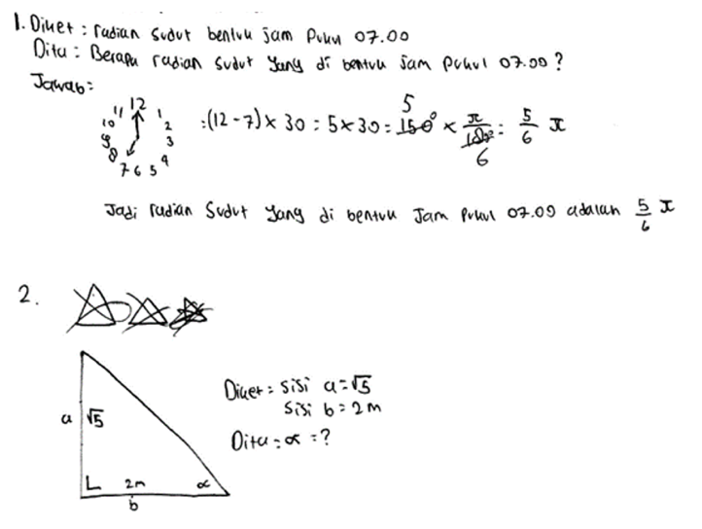(a) Original answer from the subject | 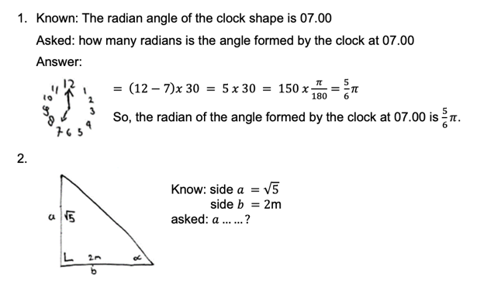  (b) Translation
Figure 6. The Example Solving of Session 1 in First Baseline
Figure 6 shows that the subject is still having difficulty solving the problem. The subject only wrote the known interpretation and asked for both problems. In Problem 1, the subject wrote an arrangement, but there was no analysis provided. Meanwhile, the evaluation was not detailed, and the inference section was incomplete. Then, in Problem 2, the error was that the subject did not understand the problem, so the subject can only wrote what is known and what is asked. So, it can be concluded that the subject did not understand the problem and was unable to write the interpretation, analysis, evaluation, and inferences from solving the problem. However, this was also seen while working on the problems by the subject. The subject looked puzzled, often asked about solving the problem and complained several times being confused.
In the intervention phase, subjects were given the treatment by applying Tri-N based learning (Niteni, Nirokke, Nambahi) using PowerPoint. The results of the sample tests carried out by the subject in the intervention phase are shown in Figure 7.

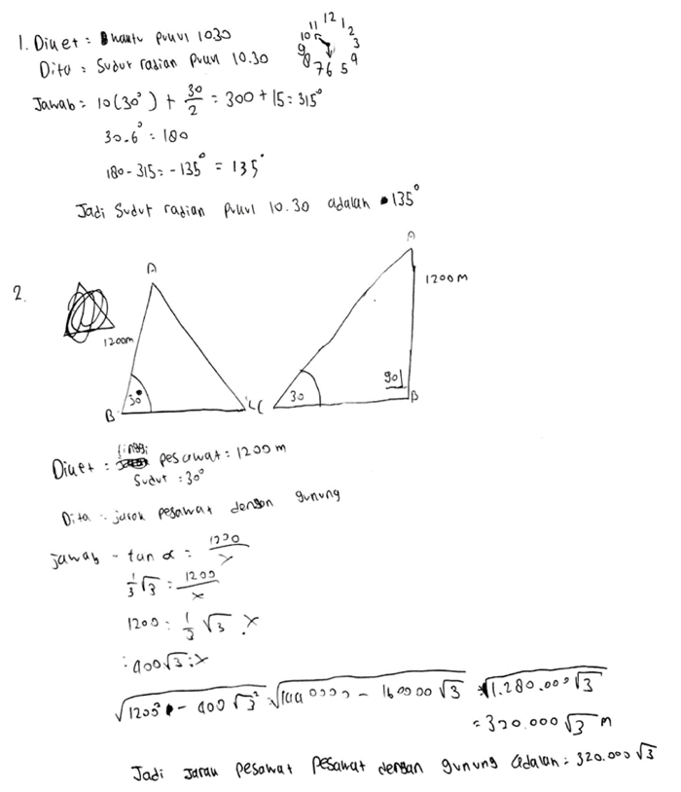  - Original answer from the subject | 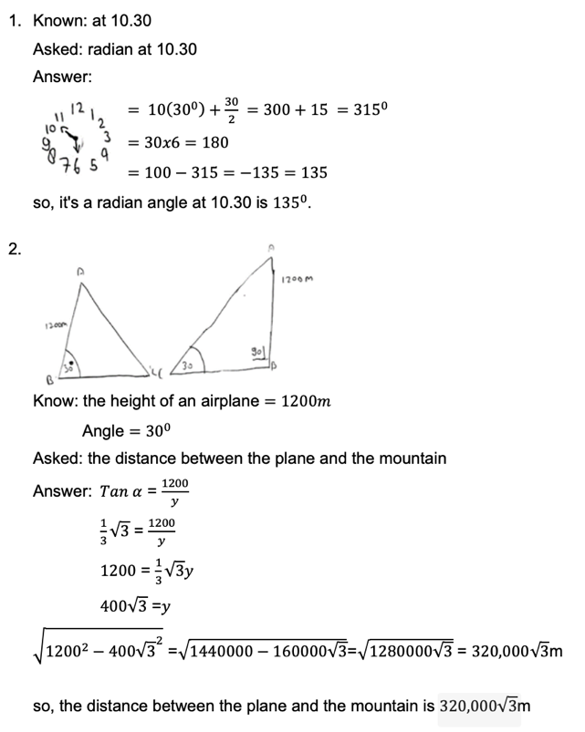  (b) Translation
Figure 7. The Example Solving of Session 1 in Intervention
Figure 7 shows that the results of the subject's work have improved in the completion stage compared to the first baseline, including interpretation, analysis, and evaluation. However, these stages remained incomplete. In Problem 1, the subject's analysis stage only described the hours and their numbers without explaining the division of degrees obtained during the evaluation stage. The calculations at the evaluation stage were incorrect. That is, when subtracting numbers that should be large, subtract small numbers so that the results are incorrect. In Problem 2, the subject had written an interpretation and analysis, but in the evaluation, the calculation was incorrect. So, it can be concluded that Tri-N-based learning (Niteni, Nirokke, Nambahi) can help subjects understand the material and solve trigonometry problems.
Next, the second baseline phase (A') is intended to examine whether the treatment affects the subject. The results show that the critical thinking skills tests at this stage have improved, better than the first baseline (A) and the intervention phase (B). In addition, the subject fulfilled all four indicators of critical thinking skills at the second baseline. Figure 8 shows the subject's effort in solving the critical thinking test questions at the second baseline.

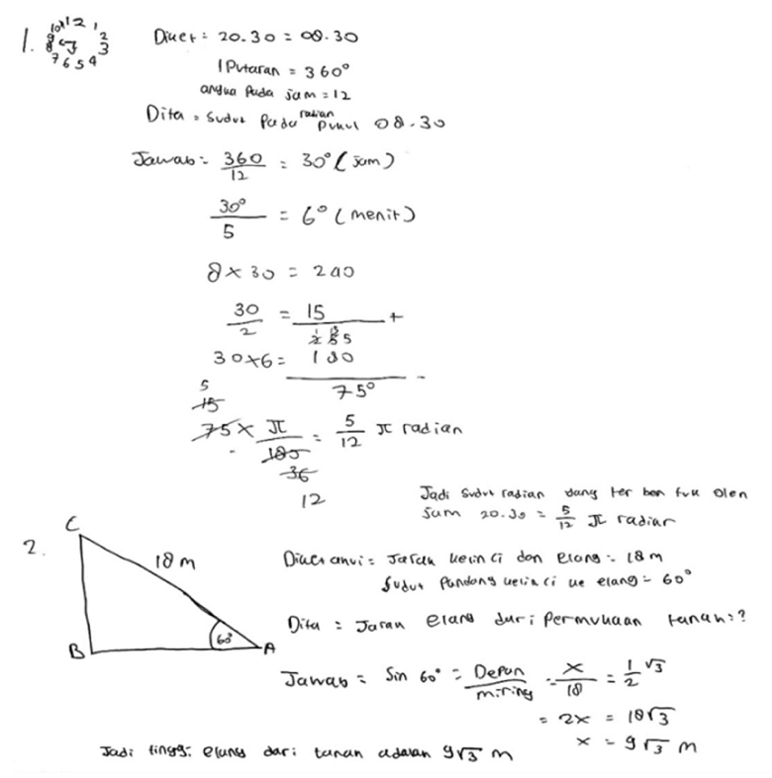  (a) Original answer from the subject | 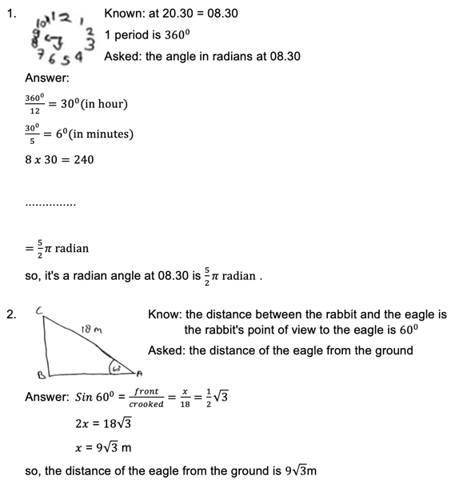  (b) translation
Figure 8. The Example Solving of Session 1 in the Second Baseline
Based on Figure 8, it is evident that the subject performed well in the critical thinking skills test. In Problems 1 and 2, all four indicators featured detailed and accurate calculations. The test results in the second baseline (A') exhibited improvement. In essence, Tri-N-based learning (Niteni, Nirokke, Nambahi) has a positive impact on enhancing the critical thinking skills of students with sanguine personalities in trigonometry. Utilizing Tri-N (Niteni, Nirokke, Nambahi) for students with sanguine personalities encourages observation, imitation, and creativity in problem-solving. Through Tri-N learning, sanguine students exhibit increased focus and a sense of being cared for by the teacher.
CONCLUSION
The results and discussion demonstrate that Tri-N-based learning (Niteni, Nirokke, Nambahi) can enhance critical thinking skills in Year 10 students with sanguine personalities, particularly in trigonometry. This improvement is evident in the critical thinking skills scores, which increased from the first baseline (A) to the intervention phase (B) and further rose in the second baseline (A'). The subjects achieved an average score that escalated from 30 in the first baseline (A) to 70 in the intervention phase (B) and further increased to 89.58 in the second baseline (A'). Moreover, the effectiveness of the intervention is substantiated by the low overlap percentage of 0% between the first baseline (A) and the intervention (B), as well as between the intervention (B) and the second baseline (A'). A smaller overlap percentage indicates a more successful intervention for the research subjects. The 0% overlap signifies that the Tri-N learning intervention positively influences the critical thinking skills of students with sanguine personalities.
ACKNOWLEDGMENT
We would like to thank all those who helped complete this research article. We express our special thanks to the research subjects who have agreed to produce data in this study and to Universitas Sarjanawiyata Tamansiswa, who have helped us immaterially in this research.
REFERENCES
Afiani, K. D. A., & Faradita, M. N. (2021). Analisis Aktivitas Siswa dalam Pembelajaran Daring Menggunakan Ms. Teams pada Masa Pandemi Covid-19. Jurnal Pemikiran Dan Pengembangan Sekolah Dasar, 9(1), 16–27. https://doi.org/10.22219/jp2sd.v9i1.15971

Aiken, L. H., & Patrician, P. A. (2000). Measuring Organizational Traits of Hospitals: The Revised Nursing Work Index. Nursing Research, 49(3), 146–153. https://doi.org/10.1097/00006199-200005000-00006

Aiken, L. R. (1980). Content Validity and Reliability of Single Items or Questionnaires. Educational and Psychological Measurement, 40(4), 955–959. https://doi.org/10.1177/001316448004000419

Aiken, L. R. (1999). Personality Assessment Methods and Practices (3rd Ed). Hogrefe&Huber Publishers.

Almanasreh, E., Moles, R., & Chen, T. F. (2019). Evaluation of methods used for estimating content validity. Research in Social and Administrative Pharmacy, 15(2), 214–221. https://doi.org/10.1016/j.sapharm.2018.03.066

Anggreini, D., Priyojadmiko, E., & Setiana, D. (2020). Analisis Koneksi Matematika Ditinjau dari Tipe Kepribadian Sanguinis, Koleris, Melankolis, dan Plegmatis. Buana Matematika: Jurnal Ilmiah Matematika Dan Pendidikan Matematika, 10(1), 71–88. https://doi.org/10.36456/buanamatematika.v10i1.2406

Arifianti, V., & Ismail. (2018). Profil Berpikir Kritis Siswa SMA Dalam Pemecahan Masalah Aplikasi Turunan Fungsi Ditinjau Dari Tipe Kepribadian Sanguinis dan Phlegmatis. Mathedunesa: Jurnal Ilmiah Pendidikan Matematika, 7(3), 526–532. https://doi.org/10.26740/mathedunesa.v7n3.p526-532

Arum, C. S. (2021). Korelasi Tipe Kepribadian Terhadap Prestasi Belajar Matematika Kelas V Di Sdn 1 Tanjung Pandan Kecamatan Lampung Tengah. UIN Raden Intan Lampung, 11–15.

Azis, N. A. (2018). Profil keterampilan berpikir kreatif siswa dalam memecahkan masalah matematika ditinjau dari kepribadian. Matematika Dan Pembelajaran, 6(2), 143–157. https://doi.org/10.33477/mp.v6i2.666

Buckingham, R. M. (2002). Extraversion, neuroticism and the four temperaments of antiquity: an investigation of physiological reactivity. Personality and Individual Differences, 32(2), 225–246. https://doi.org/10.1016/S0191-8869(01)00020-4

Crocker, L. (2015). Content Validity. International Encyclopedia of the Social & Behavioral Sciences: Second Edition, 01, 774–777. https://doi.org/10.1016/B978-0-08-097086-8.44011-0

Damayanti, S., & Rochmiyati, S. (2019). Telaah penerapan tri-n ( niteni, nirokke, nambahi ) pada buku Bahasa Indonesia kelas IX smp. Jurnal Muara Pendidikan, 4(2), 388–397. https://doi.org/10.52060/mp.v4i2.174

Doody, J. A., & Immerwahr, J. (1983). The persistence of the four temperaments. Soundings: An Interdisciplinary Journal, 66(3), 348–359. http://www.jstor.org/stable/41178265

Dores, O. J., Wibowo, D. C., & Susanti, S. (2020). Analisis Kemampuan Berpikir Kritis Siswa Pada Mata Pelajaran Matematika. J-Pimat, 2(3), 242–254. https://doi.org/10.31932/j-pimat.v2i2.889

Duron, R., Limbach, B., & Waugh, W. (2006). Critical thinking framework for any discipline. International Journal of Teaching and Learning in Higher Education, 17(2), 160–166.

Ermawati, E., & Rochmiyati, S. (2020). Implementasi Tri-N (Niteni-nirokke-nambahi) dan PPK (Penguatan Pendidikan Karakter) pada Perangkat Pembelajaran Teks Deskripsi Kelas VII di SMP. Jurnal Pendidikan Bahasa Dan Sastra Indonesia, 9(1), 8–13. https://doi.org/10.15294/jpbsi.v9i1.35756

Ernest, P., Skovsmose, O., Van Bendegem, J. P., Bicudo, M., Miarka, R., Kvasz, L., & Moeller, R. (2016). The philosophy of mathematics education. Springer Nature. https://library.oapen.org/bitstream/handle/20.500.12657/27750/1/1002255.pdf

Fadillah, S. (2009). Kemampuan Pemecahan Masalah Matematis dalam Pembelajaran Matematika. Prosiding Seminar Nasional Penelitian, Pendidikan Dan Penerapan MIPA, Fakultas MIPA, Universitas Negeri Yogyakarta, 553–338.

Falahudin, I., Wigati, I., & Astuti, A. P. (2016). Pengaruh model pembelajaran inkuiri terbimbing terhadap kemampuan berpikir kritis siswa pada pembelajaran materi pengelolaan lingkungan di SMP Negeri 2 Tanjung Lago, Kabupaten Banyuasin. Bioilmi: Jurnal Pendidikan, 2(2). https://doi.org/10.19109/bioilmi.v2i2.1133

Fitria, C., & Siswono, T. Y. E. (2014). Profil Keterampilan Berpikir Kreatif Siswa Dalam Memecahkan Masalah Matematika Ditinjau Dari Tipe Kepribadian (Sanguinis, Koleris, Melankolis, dan Phlegmatis). Mathedunesa: Jurnal Ilmiah Pendidikan Matematika, 3(3), 23–32. https://doi.org/10.26740/mathedunesa.v3n3.p%25p

Gast, D. L., & Ledford, J. R. (2014). Single subject research methodology in behavioral sciences. In New York: Routledge. Routledge.

Harsanto, R. (2005). Melatih anak berpikir analitis, kritis, dan kreatif. Jakarta: Grasindo.

Hastari, R. C., & Wardani, T. K. (2022). Profil Proses Berpikir Kritis Siswa dalam Memecahkan Masalah Matematika Ditinjau dari Tipe Kepribadian Afiliation. Edu Cendikia: Jurnal Ilmiah Kependidikan, 2(2), 377–390. https://doi.org/10.47709/educendikia.v2i2.1693

Heryati, E., Tarsidi, I., & Suherman, Y. (2022). Pelatihan Penyusunan Proposal Penelitian Subjek Tunggal (Single Subject Research) Bagi Guru-Guru SLB. Empowerment: Jurnal Pengabdian Masyarakat, 5(2), 229–235. https://doi.org/10.25134/empowerment.v5i02.4878

Hidayat, F., Akbar, P., & Bernard, M. (2019). Analisis Kemampuan Berfikir Kritis Matematik Serta Kemandiriaan Belajar Siswa SMP Terhadap Materi SPLDV. Journal on Education, 1(2), 515–523. https://doi.org/10.31004/joe.v1i2.106

Hidayati, H., & Khasanah, D. (2020). Pengembangan Lembar Kerja Mahasiswa Mata Kuliah Gelombang dan Bunyi Berbasis Niteni, Nirokke, Nambahi. WACANA AKADEMIKA: Majalah Ilmiah Kependidikan, 4(2), 75–82. https://doi.org/10.30738/wa.v4i2.6130

Ibrahim, I., Sujadi, I., Maarif, S., & Widodo, S. A. (2021). Increasing Mathematical Critical Thinking Skills Using Advocacy Learning with Mathematical Problem Solving. Jurnal Didaktik Matematika, 8(1), 1–14. https://doi.org/10.24815/jdm.v8i1.19200

Istiqomah, J. Y. N., & Indarini, E. (2021). Meta Analisis Efektivitas Model Problem Based Learning dan Problem Posing Terhadap Kemampuan Berpikir Kritis Siswa Sekolah Dasar Pada Pembelajaran Matematika. Jurnal Cendekia : Jurnal Pendidikan Matematika, 5(1), 670–681. https://doi.org/10.31004/cendekia.v5i1.553

Istiqomah, N., Arigiyati, T. A., Wijayanti, A., & Widodo, S. A. (2021). Validitas E–LKPD Matematika Berbasis Tri N Pada Pokok Bahasan Bentuk Aljabar. Wacana Akademika: Majalah Ilmiah Kependidikan, 5(2), 113–120.

Janah, S. R., Suyitno, H., & Rosyida, I. (2019). Pentingnya Literasi Matematika dan Berpikir Kritis Matematis dalam Menghadapi Abad ke-21. PRISMA, Prosiding Seminar Nasional Matematika, 2, 905–910.

Karbalaei, A. (2012). Critical thinking and academic achievement. Íkala, Revista de Lenguaje y Cultura, 17(2), 121–128. http://www.scielo.org.co/pdf/ikala/v17n2/v17n2a1.pdf

Kemmis, S., McTaggart, R., & Nixon, R. (2014). The action research planner: Doing critical participatory action research. In The Action Research Planner: Doing Critical Participatory Action Research. https://doi.org/10.1007/978-981-4560-67-2

Kivunja, C. (2014). Do You Want Your Students to Be Job-Ready with 21st Century Skills? Change Pedagogies: A Pedagogical Paradigm Shift from Vygotskyian Social Constructivism to Critical Thinking, Problem Solving and Siemens’ Digital Connectivism. International Journal of Higher Education, 3(3), 81–91. https://doi.org/10.5430/ijhe.v3n3p81

Lane, J. D., & Gast, D. L. (2014). Visual analysis in single case experimental design studies: Brief review and guidelines. Neuropsychological Rehabilitation, 24(3–4), 445–463. https://doi.org/10.1080/09602011.2013.815636

Mahmuzah, R. (2015). Peningkatan Kemampuan Berpikir Kritis Matematis Siswa SMP Melalui Pendekatan Problem Posing. Jurnal Peluang, 4(1), 64–72.

Nilamsari, D. M., & Fitriyani, H. (2021). Student’s Thinking Process in Geometry Problem Solving Reviewed from Personality Types Hippocrates-Galenus. Edumatica: Jurnal Pendidikan Matematika, 11(02), 18–28. https://doi.org/10.22437/edumatica.v11i02.12120

Nisa, A. F., Prasetyo, Z. K., & Istiningsih, I. (2019). Tri N (Niteni, Niroake, Nambahake) Dalam Mengembangkan Kreativitas Siswa Sekolah Dasar. El Midad, 11(2), 101–116. https://doi.org/10.20414/elmidad.v11i2.1897

Octaviani, C., Hartoyo, A., & Sayu, S. (2018). Proses Penyelesaian Masalah Berdasarkan Tahapan Polya Ditinjau dari Tipe Kepribadian Siswa Kelas XI SMA. Jurnal Pendidikan Dan Pembelajaran Khatulistiwa (JPPK), 7(6), 1–9. https://doi.org/10.26418/jppk.v7i6.25873

Oda, F. E., Budhi, W., & Hasanah, D. (2022). Development of Electronic Student Worksheet based on Tri-N (Niteni, Nirokke, Nambahi) on Temperature and Heat topic for XI Grade of SMA PIRI 1 Yogyakarta. SNPF (Seminar Nasional Pendidikan Fisika).

Peter, E. E. (2012). Critical thinking: Essence for teaching mathematics and mathematics problem solving skills. African Journal of Mathematics and Computer Science Research, 5(3). https://doi.org/10.5897/AJMCSR11.161

Prahmana, R. C. I. (2021). Single Subject Research (Teori dan Implementasinya: Suatu Pengantar). Yogyakarta: Universitas Ahmad Dahlan.

Priyadi, R., Mustajab, A., Tatsar, M. Z., & Kusairi, S. (2018). Analisis kemampuan berpikir kritis siswa SMA kelas X MIPA dalam pembelajaran fisika. JPFT (Jurnal Pendidikan Fisika Tadulako Online), 6(1), 53–55. http://jurnal.untad.ac.id/jurnal/index.php/EPFT/article/view/10020

Putri, A. (2018). Profil Kemampuan Berpikir Kritis Matematis Siswa SMP Kelas VIII Materi Bangun Ruang Sisi Datar. Jurnal Pendidikan Tambusai, 2(4), 793–801. https://doi.org/10.31004/jptam.v2i4.26

Rachmadtullah, R., Yustitia, V., Setiawan, B., Fanny, A. M., Pramulia, P., Susiloningsih, W., Rosidah, C. T., Prastyo, D., & Ardhian, T. (2020). The challenge of elementary school teachers to encounter superior generation in the 4.0 industrial revolution: Study literature. International Journal of Scientific & Technology Research, 9(4), 1879–1882.

Rakhmanina, L., Martina, F., & Jayadi, N. (2020). The comparison study on two-types of students personality: Sanguine and phlegmatic toward their English speaking ability. Project: Professional Journal of English Education, 3(4), 443–452. https://doi.org/10.22460/project.v3i4.p443-452

Ramadhan, R. A., Mulya, D., & Utami, Y. T. (2022). Pengaruh metode bermain peran terhadap perilaku agresif anak dengan hambatan pendengaran. Jurnal Unik: Pendidikan Luar Biasa, 7(1), 7–11. https://doi.org/10.30870/unik.v7i1.12955

Retnawati, H. (2016). Analisis Kuantitatif Instrumen Penelitian (Panduan Peneliti, Mahasiswa, dan Psikometrian) (Pertama). Parama Publishing.

Rochmiyati, S., & Putro, D. B. W. (2020). Penerapan Tri-N Pada Buku Siswa Bahasa Indonesia VIII Dalam Upaya Meningkatkan Keterampilan Berbahasa. Wacana Akademika: Majalah Ilmiah Kependidikan, 4(1), 48–55.

Sardia, S., & Ilyas, M. (2020). Kemampuan Penalaran Siswa Sanguinis Dalam Memecahkan Masalah Matematika Ditinjau Berdasarkan Gender. Pedagogy: Jurnal Pendidikan Matematika, 5(2), 135–144. https://doi.org/10.30605/pedagogy.v5i2.421

Sardia, S., Ma’rufi, M., & Ilyas, M. (2020). Kemampuan Penalaran Siswa Sanguinis Dalam Memecahkan Masalah Matematika Ditinjau Berdasarkan Gender. Pedagogy: Jurnal Pendidikan Matematika, 5(2), 135–144. https://doi.org/10.30605/pedagogy.v5i2.421

Scriven, M., & Paul, R. (1996). Defining critical thinking: A draft statement for the National Council for Excellence in Critical Thinking. Available Onlien at: Http://Www. Criticalthinking. Org/University/Univlibrary/Library. Nclk [Accessed in Manila, Philippines: September 19, 2016].

Setyawati, E., Susilawati, S., & Sulisworo, D. (2018). Analysis of metacognition difficulties in problem-solving static fluid material in term of Hippocrates â€“Galenus personality type. Indonesian Review of Physics, 1(2), 42–47. https://doi.org/10.12928/irip.v1i2.780

Shadiq, F. (2004). Penalaran, Pemecahan Masalah dan Komunikasi dalam Pembelajaran Matematika. P4TK MAtematika.

Sireci, S. G. (1998). The Construct of Content Validity. Social Indicators Research, 45(1–3), 83–117. https://doi.org/10.1023/A:1006985528729

Skovsmose, O. (2020). Critical mathematics education. Springer.

Sulistiani, E., & Masrukan. (2016). Pentingnya Berpikir Kritis dalam Pembelajaran Matematika untuk Menghadapi Tantangan MEA. Seminar Nasional Matematika X Universitas Semarang, 605–612.

Sumanto, J., Takeuchi, K., & Nakata, H. (2005). Pengantar Penelitian Dengan Subyek Tunggal. CRICED University of Tsukuba, 1–150.

Sunarsih, S., Nisa, A. F., Mulyani, M., & Muhtar, M. (2023). Implementasi Ajaran Tri N Terintegrasi Model Problem-Based Learning Dalam Meningkatkan Hasil Belajar dan Berpikir Kritis Siswa Kelas 6 SD. JS: Jurnal Sekolah, 7(3), 446–454. https://doi.org/10.24114/js.v7i3.45418

Tanujaya, B., Mumu, J., & Margono, G. (2017). The Relationship between Higher Order Thinking Skills and Academic Performance of Student in Mathematics Instruction. International Education Studies, 10(11), 78–85. https://doi.org/10.5539/ies.v10n11p78

Thalhah, S. Z., Tayeb, T., Raupu, S., & Arifanti, D. R. (2020). Mathematical representation based on personality types. Lentera Pendidikan: Jurnal Ilmu Tarbiyah Dan Keguruan, 23(1), 141–157. https://doi.org/10.24252/lp.2020v23n1i12

Umar, U., Kaharuddin, A., Fauzi, A., Widodo, A., Radiusman, R., & Erfan, M. (2020). A Comparative study on critical thinking of mathematical problem solving using problem based learning and direct intruction. 1st Annual Conference on Education and Social Sciences (ACCESS 2019), 314–316. https://doi.org/10.2991/assehr.k.200827.079

Widarni, E. L., & Mora, A. G.-O. (2021). How to Understand and Develop Humans: Based on Psychology and Management Perspectives for Better Human Resources and Organizational Performance. BookRix.

Widjajanti, D. B. (2009). Kemampuan Pemecahan Masalah Matematis Mahasiswa Calon Guru Matematika: Apa Dan Bagaimana Mengembangkannya. Prosiding Seminar Nasional Matematika Dan Pendidikan Matematika, 1–11.

Widodo, S. A., Cahyani, E. R., & Istiqomah, I. (2020). Single Subject Research : Learning Algebra Operations in Introverted Students. Formatif: Jurnal Ilmiah Pendidikan MIPA, 10(2), 133–142. https://doi.org/10.30998/formatif.v10i2.6300

Widodo, S. A., Ibrahim, I., Hidayat, W., Maarif, S., & Sulistyowati, F. (2021). Development of Mathematical Problem Solving Tests on Geometry for Junior High School Students. Jurnal Elemen, 7(1), 221–231. https://doi.org/10.29408/jel.v7i1.2973

Widodo, S. A., Kustantini, K., Kuncoro, K. S., & Alghadari, F. (2021). Single Subject Research: Alternatif Penelitian Pendidikan Matematika di Masa New Normal. Journal of Instructional Mathematics, 2(2), 78–89. https://doi.org/10.37640/jim.v2i2.1040

Widyawati, A., Setyawan, D. N., & Kuncoro, K. S. (2019). Desain e-book petunjuk praktikum IPA berbasis tri N (niteni, nirokke, nambahi). Compton: Jurnal Ilmiah Pendidikan Fisika, 6(2), 46–56. https://doi.org/10.30738/cjipf.v6i2.6096

Wijayanti, N., Arigiyati, T. A., Aulia, F., & Widodo, S. A. (2021). Development of E-Worksheet on Linear Equations and Inequalities Topics Based on Tri-N. Journal of Medives: Journal of Mathematics Education IKIP Veteran Semarang, 5(2), 245–260. https://doi.org/10.31331/medivesveteran.v5i2.1650

